REQUEST FOR PROPOSALS
FOR
FRAUD RISK ASSESSMENT SERVICES

- The Town of Halifax is seeking proposals from qualified firms to provide fraud risk assessment services. Request for Proposal forms may be obtained at the Board of Selectmen’s Office, 499 Plymouth Street, Halifax, MA 02338 or the Town’s web site - halifax-ma.org - Proposals will be received at the Board of Selectmen’s Office until 3:00 p.m, on Monday, May 3, 2021 at which time no further proposals will be accepted. The Halifax Board of Selectmen will make the award for this contract. The Town of Halifax reserves the right to reject any or all proposals

TOWN OF HALIFAX, MA

REQUEST FOR PROPOSALS
FOR
FRAUD RISK ASSESSMENT SERVICES

GENERAL INFORMATION

1. INTRODUCTION
The Town of Halifax, MA (herein after referred to as “Town”) is seeking proposals from qualified firms to undertake a fraud risk assessment of town government operations.

2. INQUIRIES
All inquiries regarding this RFP must be addressed to:

Charlie Seelig
Charlie.seelig@halifax-ma.org
Halifax Town Hall
499 Plymouth Street
Halifax, MA 02338

3. INCURRING COST
The Town will not be held responsible for any costs incurred by any Proposer for work performed in the preparation and production of their proposal or for any work performed prior to the signing of a contract.

4. REJECTION OF PROPOSAL
The Town reserves the right to reject any or all proposals in whole or in part or to waive any informality or technicality, irregularity or omissions if the Town determines that it is in its best interest to do so.

5. PROJECT TIMETABLE
The proposed project schedule for this RFP is as follows:

RFP Published: ........................................................................April 16, 2021
RFP Questions Due (no later than): .......................................April. 26, 201
RFP Due: ...................................................................................May 3, 2021
RFP Evaluation and Award: ...................................................May 2021
Contract Negotiation and TOWN Approval: ........................June 2021

Please note that the above dates are estimates and are subject to change.

6. PERTINENT DATE
One (1) signed original and (1) copy of the proposal documents must be received at the address below on or before 3:00 p.m. on Monday, May 3, 2021. Proposals received after that time and date will not be considered and will be returned unopened. Submittal packages must be in a sealed envelope and clearly marked: “TOWN OF HALIFAX, MA RFP-FRAUD RISK ASSESSMENT SERVICES”.

All copies of proposals shall be submitted in sealed packages addressed to:

Charlie Seelig
Halifax Town Hall
499 Plymouth Street
Halifax, MA 02338

7. PROPRIETARY INFORMATION
Proprietary data or trade secrets should be clearly identified as such in the proposal. The Town will not disclose any portion of the proposals except to members of the evaluation team prior to contract award. The Town reserves the right to disclose the name of the successful proposer, the financial considerations, and any other information in the proposal that was pertinent to the selection of the Proposer.

8. INDEPENDENT PROJECT COST DETERMINATION AND GRATUITIES
By submission of a proposal, the Proposer certifies that:

- Costs associated with this request have been arrived at independently, without consulting, communication, or agreement for the purpose of restricting competition, as to any matter relating to such prices with any other Proposer or Competitor;
- Unless otherwise required by law, the costs which have been included in this offer have not been knowingly disclosed by the Vendor and will not knowingly be disclosed by the Vendor prior to award, directly or indirectly to any other Vendor or to any Competitor; and no attempt has been made or will be made by the Vendor to induce any other person or firm to submit or not to submit an offer for the purpose of restrictive competition.
- No elected official, appointed official or employee of the Town shall benefit financially or materially from this contract.

9. TERMINATION FOR DEFAULT OR FOR THE CONVENIENCE OF THE

CONTRACTING AGENCY
The contract resulting from this RFP may be terminated by the Town whenever:

- The Proposer, in the sole opinion of the TOWN, is in default of their performance of the contract and has failed to correct such default within the period specified by the TOWN.
- Termination will be effected by delivery to the Proposer of a notice to terminate, stating the date upon which the termination becomes effective. Upon receipt of the notice to terminate, the Proposer shall:
  - Prepare to stop all work by the termination date.
  - Meet with the Town’s representative to review work in progress to determine time critical tasks and to take such action as is necessary to protect the Town’s rights.
  - Cooperate and participate when needed in the orderly transition of the work being performed by the Proposer.

10. AMBIGUITY IN THIS REQUEST FOR QUALIFICATION
Prior to submitting a response to this request, it is the responsibility of the Proposer to bring to the attention of the Town any ambiguity in this document. To not do so shall result in the Proposer forfeiting any claim for additional compensation based on such ambiguity as should have been noted by a prudent Proposer.

11. OWNERSHIP INFORMATION
The Town shall have unlimited right to use, disclose, or duplicate, for any purpose whatsoever, all information developed, derived, documented, or furnished by the Proposer under any contract resulting from this RFP.

In the event of contract award, all data collected and other documentation produced as part of the contract will become the exclusive property of the Town and may not be copied or removed by any employee of the Proposer without written permission of the Town.

12. CONTRACT AGREEMENT
The selected Proposer will be required to agree to and sign a formal written contract between the Town and said Proposer.

13. INSURANCE REQUIREMENTS
The Proposer awarded a contract under this request for proposals shall submit to the Town within ten (10) days from notice of contract award, Certificates of Insurance evidencing the following required coverage:

A) General Liability of at least $1,000,000 Bodily Injury and Property Damage Liability, Combined Single Limit with a $3,000,000 Annual Aggregate Limit. The Town should be named as an "Additional Insured". Products and Completed Operations should be maintained for up to 3 years after the completion of the project.

B) Automobile Liability (applicable for any contractor who has an automobile operating exposure) of at least $1,000,000 Bodily Injury and Property Damage per accident. The Town should be named as an "Additional Insured".

C) Workers' Compensation Insurance as required by law. Architects and Engineers Professional Liability (applicable for any architects or engineers involved in the project) of at least $1,000,000/occurrence, $3,000,000 aggregate. The Town should be named as an Additional Insured.

D) Property Coverage for materials and supplies being transported by the contractor, as the Town’s Property Contract provides coverage for personal property within 1000 feet of the premises.

E) Umbrella Liability of at least $5,000,000/ occurrence, $5,000,000/aggregate. The Town should be named as an Additional Insured.

F) Waiver of Subrogation - The Town will delete any Waiver of Subrogation Language in its entirety from any contract the Municipality enters into.

PROJECT SCOPE

1. GENERAL DESCRIPTION
The Town of Halifax operates under a Board of Selectmen/Town Administrator form of government. The Board is composed of three members who are elected for three-year terms. The Town Administrator is hired by the Board of Selectmen. The Town Administrator is not specifically responsible for the operations of any department except for the Selectmen’s Office and Data Processing. Other Departments are under the jurisdiction of elected officials and/or boards and officials appointed by the Board of Selectmen. The Halifax Elementary School falls under the jurisdiction of the elected Halifax Elementary School Committee. Grades 7-12 are part of the Silver Lake Regional School District which is a separate governmental entity with a separately elected School Committee. Town operations are divided into six broad categories including the Schools. The Town has approximately 65 full-time, non-school employees, approximately 60 full-time, school employees and a total financial operation of approximately $26 million.

2. SCOPE OF SERVICES
▪ The Town desires to engage a qualified firm to provide an assessment of the potential risk for fraud based on the Town’s current policies and procedures. ▪ The firm selected will be required to issue a report that:
- Identifies areas most vulnerable to fraud;
- Determines if adequate fraud prevention measures exist;
- Identify opportunities to reduce the cost of fraud.

RESPONSE

1. CONTRACTOR QUALIFICATION REQUIREMENTS
All proposers must have a minimum of five (5) years’ experience undertaking fraud risk assessments, preferably in the government sector, and have demonstrated an expertise and proven record of identifying the potential for fraud and providing solutions to improve an organizations internal control measures.

2. RESPONSE FORMAT
Proposal responses should be no more than 10 pages and specifically include:

- Letter of Interest - Provide a letter of interest signed by a Principal or Officer, describing in narrative form your firm and its qualifications that will assist the Town in making its selection. This statement should include the specific individuals in the firm who will be assigned to the Town.
- Firm Description - Provide a description and brief history of the firm. Include firm name; location of principal office and branch offices; and length of time in business.
Firms shall provide a “Certificate of Good Standing” from their home state.

- Litigation/Arbitration - List information on any involvement in litigation or arbitration with a previous or current client. Explain the circumstances that led to it and describe the resolution.
- Insurance - Identify your professional liability insurance carrier and policy limits and attach a copy of a certificate of insurance.
- Any other information that, in the judgment of the firm, will allow the Town to make a fair assessment of your experience and abilities. This will include the ability to perform the necessary work including any in-person work in Halifax.

- Costs – Proposals should include all costs associated with providing the services described in the Scope of Work. Proposals may include a compensation approach that includes the hourly rate for each individual who would be assigned to the Town. Your firm’s normal compensation method if different from the above approaches should also be proposed.

3. EVALUATION CRITERIA
In addition to the quality of the information contained in their submission, Proposers will be evaluated based on:
- The competence and reputation of the firm.
- The firm’s background and experience providing similar tasks for other comparable entities.
- Expertise and knowledge of rules and regulations mandated by the Local, State, and Federal Government entities.
- Qualifications and experience of key personnel and identified employees who will be assigned to work with the Town.
- The firm’s current workload and ability to provide services within the time allotted.

4. SELECTION PROCESS
The Town may select certain firms to make presentations. Each presenting firm will be asked to make a formal presentation at an interview followed by a question and answer period. Final approval will be made based on criteria deemed to be in the best interest of the Town.

5. HOLD HARMLESS AGREEMENT
In addition to its obligation to provide insurance as specified above, the selected firm, its agents and assigns shall indemnify and hold harmless the Town of Halifax including, but not limited to, its elected officials, its officers and agents from any and all claims made against the Town, including, but not limited to, damages, awards, costs and reasonable attorneys’ fees, to the extent any such claim directly and proximately results from the wrongful, willful or negligent performance of services by the selected firm during the performance of this Agreement or any other Agreement of the firm entered into reason thereof. The Town agrees to give the firm prompt notice of any such claim.

6. TOWN OPTIONS
- The Town reserves the right to reject any or all proposals and to waive any requirements, irregularities, technical defects or service therein when it is deemed to be in the best interest of the Town to do so.
- If a proposal does not meet or exceed the required specifications and requirements contained herein, on all points, that must be outlined in a letter otherwise it will be presumed that a proposal is in accordance with the required specifications and requirements.
- The Town reserves the sole and exclusive right to determine whether or not a proposal meets or exceeds the stated specifications.

7. INQUIRIES
- All inquiries regarding this request must be submitted in writing and shall be answered up to the close of business on April 26, 2021 after which time no additional questions will be accepted.
- To ensure consistent interpretation of certain items, answers to questions the Town deems to be in the interest of all will be made available in writing or by fax as appropriate to all interested parties.
- Inquiries of a technical nature may be directed to Charlie Seelig, Town Administrator.
- Additionally, after inquiries are received, the Town reserves the right to communicate with any or all interested parties to clarify the provisions of Proposals.
- It is the sole responsibility of the responding firm to verify any addendums that may have been issued relating to this request prior to final submissions of a proposal. Failure to submit a proposal that does not address changes or addendums may result in disqualification of a proposal.

8. AWARD AND AUTHORITY
- The requested services shall be awarded to the Proposer whose proposal is deemed to best provide the services desired, taking into account the requirements, terms and conditions contained in the Request for Proposals and the criteria for evaluating proposals.
- The Halifax Board of Selectmen will issue a notification of award in writing.

9. ASSIGNMENT OF RIGHTS, TITLES, AND INTERESTS
Any assignment or subcontracting for work to be performed related to this request, in whole or in part, and any other interest in conjunction with Town procurement shall not be permitted without the express consent of the Town.

10. CANCELLATION AGREEMENT
The Town reserves the right to cancel any contract/agreement, at any time, with sixty (60) days prior written notice to the consultant if the Town, through changes in its requirements, method of operation, or program operation, no longer has a need for the service.

TOWN OF HALIFAX, MA REQUEST FOR PRPOSALS

FRAUD RISK ASSESSMENT SERVICES

REFERENCES (To be submitted with proposal)
Please include references for similar consulting services provided for at least three (3) clients in the past five (5) years (attach any other client references if desired). PLEASE NOTE IT IS THE
TOWN’S INTENT TO COMMUNICATE WITH THE REFERENCES LISTED HEREIN.

Client 1:
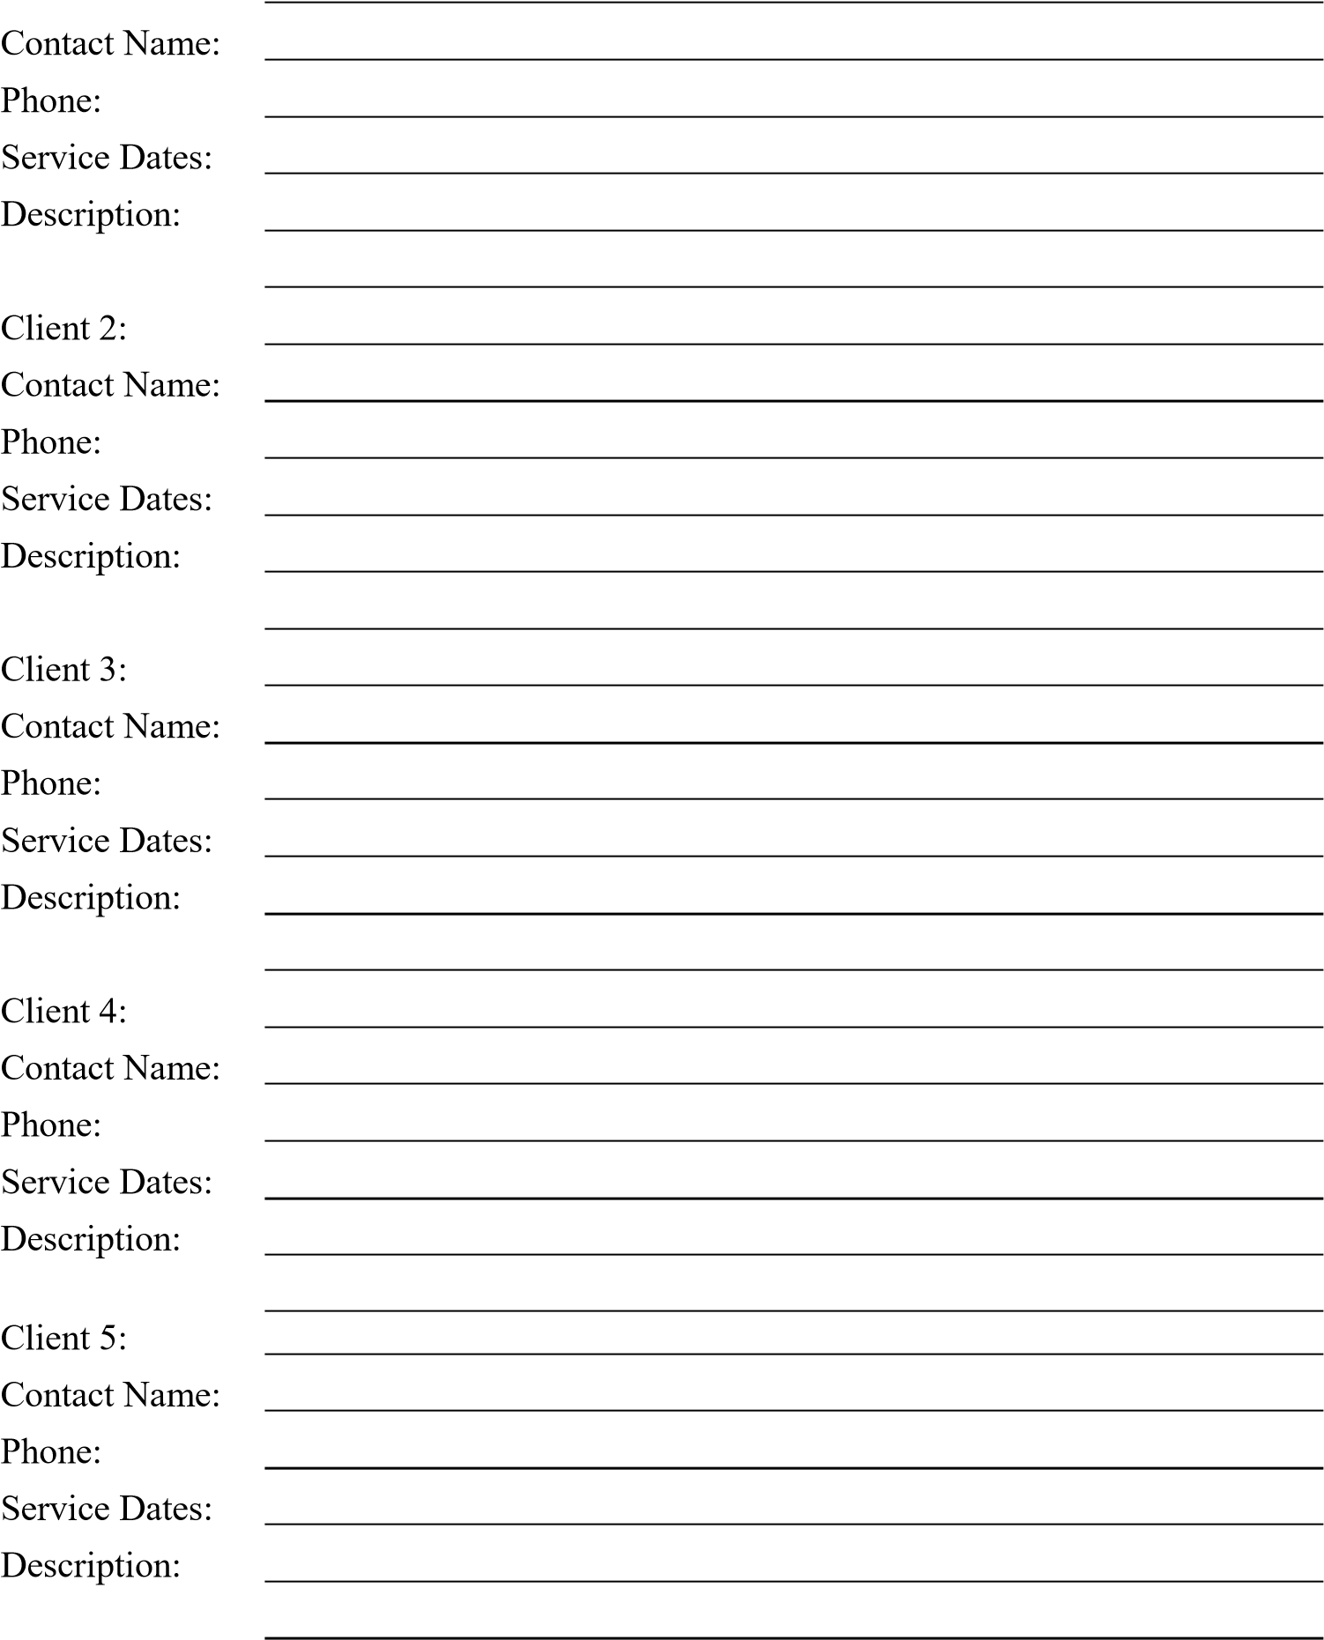

TOWN OF HALIFAX, MA REQUEST FOR PRPOSALS

FRAUD RISK ASSESSMENT SERVICES

The undersigned, in compliance with this RFP, affirms, that it has examined the specifications and related documents contained herein and proposes to provide this service in accordance with this RFP and any contract documents within the time frames set forth herein and at the prices agreed to.

The undersigned certifies that this proposal meets all the specifications, requirements and conditions requested herein. Any substitutions to the specifications requested are clearly and completely noted and attached. Any alternate proposals are presented in similar format as requested and are attached herein. It is understood that the Town reserves the right to reject any or all proposals.

Company Name |  |  |  |  | by (Signature)
Address |  |  |  |  | Print Name (A Duly Authorized Representative)
Address |  |  |  |  | Title
Date |  |  |  |  | Telephone/Fax
Email |  |  |  |  | Website

