Host Community Agreement
Between
Town of Halifax,
Massachusetts and
Flower & Soul, Inc.

This Host Community Agreement (“HCA”), dated June ___, 2021, is made by and between the Town of Halifax, a Massachusetts municipal corporation with an address of 499 Plymouth Street,
Halifax, MA 02338 (the “Town”), and Flower & Soul, Inc, a Massachusetts Corporation with a principal place of business of 800 Hingham St. Rockland MA 02370 (“Flower & Soul”). The Town and Flower & Soul collectively are referred to as the “Parties.” All capitalized terms not otherwise defined herein shall have the meanings ascribed to them by M.G.L. Ch. 94G and 935 C.M.R. 500.000.

WHEREAS, Flower & Soul intends to occupy a unit totaling approximately 1,700 square feet within the building located at 894 Plymouth Street in the Town of Halifax, as shown on the plan attached hereto as Exhibit A (the 1,700 square foot unit that Flower & Soul is using for the Marijuana Establishment being the “Premises”) to operate a Marijuana Establishment for retail sales of Marijuana and Marijuana Products and Accessories (the “Establishment” or “Marijuana
Establishment”), pursuant to M. G. L. c. 94G and the Cannabis Control Commission (the
"Commission" or the “CCC”) regulations at 935 CMR 500.00 (the “CCC Regulations”);

WHEREAS, Flower & Soul intends to submit an application to the Commission for licensure to operate the Establishment at the Premises (the “Application”);

WHEREAS, the Parties intend by this HCA to satisfy the provisions of G.L. c.94G, Section 3(d), applicable to the location of the Premises and operation of the Establishment, such activities to be conducted only in accordance with this HCA and applicable state and local laws and regulations in the Town;

WHEREAS, as part of the Application, the Parties must certify that they have executed a Host Community Agreement that sets forth the conditions to allowing the Marijuana Establishment to be located in the Town, including stipulations of responsibilities of the Parties “Commission Certification”).

NOW THEREFORE, in consideration of the premises and covenants set forth herein, the Parties agree as follows:

1. Support
Provided that the Marijuana Establishment meets all Adult Use Regulations and Local Laws, the Town agrees to provide Commission Certification to the Commission within 45 days of a request from either Flower & Soul or the Commission, and to provide such other information as may be reasonably requested by the Commission or Flower & Soul in connection with its applications for
Licenses at the Premises and to cooperate with Flower & Soul in good faith during 1
LPM 04232021
the Commission licensing process.

2. Community Impact Fee
Flower & Soul agrees that:

- For five (5) years (the “Term”) after the day Flower & Soul first commences sales from the Establishment (the "Sales Commencement Date"), with respect to all sales of Marijuana, Marijuana Products and Marijuana Accessories (hereinafter collectively referred to as "Marijuana Product") on or from the Premises, Flower & Soul shall provide annual community impact funding ("CIF") to the Town in the amount of three percent (3%) of the Gross Sales of Marijuana Product from the Premises. The term "Gross Sales" as used herein shall mean total sales as determined in accordance with generally accepted accounting principles or tax accounting methods, reduced by customer returns, if any, and not including the amount of state or local sales tax collected.

- At all times, Flower & Soul shall retain documentation on all sales from the Establishment, deliveries and distributions on or from the Premises consistent with the requirements set forth in the CCC Regulations. Flower and Soul shall provide complete, true and accurate copies of such documentation within forty-five (45) days upon request by the Town.

- In the event Flower & Soul’s obligation to provide CIF funding to the Town under this HCA is determined to be unenforceable or stricken either mutually by the Parties or by a court of competent jurisdiction after all periods of appeal have lapsed, then Flower & Soul and the Town will negotiate in good faith an amendment to the HCA or a new HCA containing provisions, including community funding provisions, that removes any unenforceable or stricken provision(s) and is otherwise substantially similar to the terms contained in this HCA within one hundred twenty (120) days following such agreement or determination, it being understood by the Parties that such new HCA shall comply with all applicable laws.

- Flower & Soul acknowledges that but for its agreement to provide CIF hereunder, the Town would not have entered into this HCA; thus, (i) in the event Flower & Soul takes any action (“Action”) to seek a determination from any regulatory authority or a decision from a state or Federal court seeking to enjoin, strike, limit or otherwise render moots its obligation to provide any or all CIF under this HCA the Town shall be entitled to recover from Flower & Soul all reasonable costs incurred, including court costs, attorney’s fees, and all other related expenses incurred in such Action, provided that the Town is the prevailing party, and (ii) in the event of any action taken by the Town against Flower & Soul arising from or related to this HCA, the Town shall be entitled to recover from Flower & Soul all reasonable costs incurred, including court costs, attorney’s fees, and all other related expenses incurred in such Action, provided that the Town is the prevailing party, and (iii) in the event the Town commences an action to collect ("Collection Action") CIF due, the Town shall be entitled to recover from Flower & Soul all reasonable costs incurred, including court costs, attorney’s fees, and all other related and reasonable expenses incurred in such Collection Action.

- According to M.G.L. Chapter 94G, Section 3(d), a "community impact fee shall be reasonably related to the costs imposed upon the municipality by the operation of the marijuana establishment..." In consideration of the foregoing, the Parties hereby acknowledge the difficulty of ascertaining actual costs imposed upon the Town as a result of the licensing of the Marijuana Establishment and agree that impacts may result in municipal budgetary and service increases that cannot be separately identified or precisely quantified; thus, Flower & Soul and the Town acknowledge and agree that all CIF payments due and payable under this HCA are reasonably related to such Town costs and each waives and releases any claim against the other to the contrary. The Parties have taken these facts into account in setting the amount of CIF payments under this HCA. The Town agrees and Flower & Soul acknowledges that: (i) the CIF payments due and payable under this HCA represent the best estimate of the real costs to be imposed on the Town reasonably related to the Marijuana Establishment, and (ii) said CIF payments represent reimbursement of costs to the Town and are not considered to be any form of penalty or tax levied against Flower & Soul. The Parties have taken the opportunity to confer with legal counsel with regard to all of the provisions set forth in this HCA.

- The parties acknowledge and agree that 935 CMR 500.103(4)(f) requires Flower & Soul to “submit as a component of the renewal application documentation that the establishment requested from its Host Community the records of any cost to [the] city or town reasonably related to the operation of the establishment, which would include the city’s or town’s anticipated and actual expenses resulting from the operation of the establishment in its community” and further that Flower & Soul “shall provide a copy of the electronic or written request, which should include the date of the request, and either the substantive response(s) received or an attestation that no response was received from the city or town.” The request is to “state that, in accordance with M.G.L.
c. 94G, § 3(d), any cost to a city or town imposed by the operation of [Flower & Soul] shall be documented and considered a public record as defined by M.G.L. c. 4, § 7, cl.
26.” Flower & Soul therefore shall comport with the requirement of the regulation.

3. Financial Reporting

Flower & Soul shall maintain its books, financial records and other compilations of data pertinent to the requirements of this HCA in accordance with standard accounting practices and the CCC Regulations.

So that Town may ensure the accuracy of CIF due, Flower & Soul shall provide the Town with the same access to its financial records which relate to determination of Gross Sales (to be treated as confidential, to the extent allowed by law) as is required by the Commission and Massachusetts Department of Revenue for purposes of obtaining and maintaining a license for the Establishment, but in any case as follows:

- Within one hundred and twenty (120) days after the end of each fiscal year,
Flower & Soul shall submit to the Town certified copies of all financial records which relate to determination of Gross Sales that it is required to submit to the Commission; and

- To the extent not previously delivered pursuant to Section 3(a), during the Term, within ninety (90) days upon request by the Town (up to twice annually), Flower & Soul shall submit a summary of its financial records which relate to the determination of the Gross Sales for that year, as (i) prepared by its regular independent financial accountant, (the “Financial Report”), and (ii) certified by such accountant to be accurate and in accordance with generally accepted accounting principles or tax accounting methods. The Financial Report shall be limited to those parts Flower & Soul’s books and financial records which relate to Gross Sales.

4. Payment Dates
The initial CIF payment to the Town shall be due and tendered on or before the fifteenth (15th) day of the month following the closing of the calendar quarter during which the Sales Commencement Date occurs (the "Initial Payment Date"), and shall be in an amount based on Gross Sales at the Establishment for that calendar quarter; thereafter, CIF shall be paid on or before the fifteenth (15th) day of the month following the closing of each calendar quarter during which the Flower & Soul has Gross Sales. Such payment obligations for sales made prior the termination of this Agreement shall survive such termination.

5. Notice of Sales Commencement
Flower & Soul will provide written notice to the Town at least thirty (30) days in advance of the anticipated Sales Commencement Date, and thereafter shall provide written notice to the Town of the actual date of its first sale from the marijuana Establishment.

6. Use of CIF
The Town may use the community impact funding, including any interest generated therefrom, in its sole discretion, consistent with the purpose and intent of Applicable Law this Agreement.

7. Taxation
At all times during the terms of this HCA, all taxable property in the Premises, both real and personal, owned or operated, used or occupied by Flower & Soul shall be assessed by the Town as taxable property. All applicable personal and real property taxes attributable to the Premises shall be paid by Flower & Soul or by the owner of the Premises.

9. Local Tax Option
Flower & Soul understands that the Town accepted M.G.L. c.64N, §3, imposing a local sales tax upon sale or transfer of Marijuana Product by a Marijuana Retailer operating within the Town at a rate of three percent (3%) per cent of the total sales price (the “Local Sales Tax”). Flower & Soul and the Town understand that compliance oversight, collection and remitting of this Local Sales Tax is the responsibility of the Massachusetts Department of Revenue. Flower & Soul and the Town understand and acknowledge that the Local Sales Tax is separate and distinct from the CIF payment referred to in Section 2(a) of this HCA.

8. Security
Flower & Soul agrees that it shall observe high security practices and implement enhanced policies and standards for monitoring the Premises and safeguarding the Premises from break-in and other intrusion, and theft of its Marijuana Product, consistent with the security requirements set forth in the CCC Regulations. Flower & Soul shall work with the Halifax Police Department in determining the scope and level of security measures taken on and about the Premises and marijuana Establishment, including but not limited to a traffic management plan, parking plan, the location of exterior security cameras to provide unobstructed surveillance of the entire Premises, fencing, Establishment security, identification of agents and other employees, and after hours contact information. Flower & Soul will maintain a cooperative relationship with the Halifax Police Department to ensure the Premises is safeguarded as aforesaid, including but not limited to periodic meetings to review operational concerns, cooperation in investigations, and reporting to the Halifax Police Department of any suspicious activities on the Premises.

9. Community Dispute Resolution
Flower & Soul agrees to work collaboratively and cooperatively with the Town and adjacent property owners, including property owners within six hundred (600’) feet of the Premises ("Adjacent Property Owners"), to address and mitigate any reasonable and justifiable concern or issue that may arise as a result of the marijuana Establishment, including, but not limited to traffic, parking, odor, noise and light and visual impacts ("Negative Impact"). In the event the Town receives three (3) or more reasonable and justifiable complaints from an Adjacent Property Owner within a two-week period with respect to substantially the same type of Negative Impact emanating from the Premises, then the Parties agree that the following protocol will be followed:

- The Town may, in its discretion, choose to investigate the complaints of Adjacent Property Owners, which may include evaluation of the complaint from the adjacent property of the complainants, and an on-site inspection of the entire Premises provided such on-site Town investigation and access to the Establishment is consistent with the CCC Regulations. Inspection of complaints may be conducted by the Town’s Building Inspector, Health Agent, Police Chief, and/or Fire Chief, or their designees, to evaluate the nature and scope of the complaint, document the conditions giving rise to the complaints, and investigate the Negative Impact on adjacent properties. In the event the Town chooses to conduct an on-site investigation of the Premises in connection with complaints from Adjacent Property Owners, the Town shall provide Flower & Soul with fortyeight (48) hour advance notice of the time of inspection, and Flower & Soul shall cooperate in the investigation and provide an authorized agent to accompany Town personnel conducting the investigation, provided such investigation and access is consistent with the CCC Regulations. Upon the completion of such investigation of the Establishment, the inspecting officials shall prepare a written Inspection Report, to be shared Flower & Soul.

- Following the completion of a written Inspection Report, the Town Administrator may convene a meeting of Town Officials/Staff to review the Inspection Report, and meet with Flower & Soul whose operations are the basis for the complaints to determine whether mitigation measures may be implemented to address the complaints. The Town may undertake further inspections and require that independent measurements of traffic, parking, noise or odors be taken. The Town and Flower & Soul shall discuss various mitigation measures to be taken by Flower & Soul, including the following, it being understood by the Parties that all such mitigation measures are not in conflict with the CCC Regulations:

  - Hiring a police detail;
  - Implementation of a parking plan;
  - Implementation of a traffic management plan;
  - Implementation of odor, light or noise control processes or technologies reasonably calculated to address the specific nature of the complaints; and,
  - Any other mitigation measures, as deemed reasonably appropriate pursuant to the Negative Impact.

- In the event Flower & Soul and the Town cannot reach an agreement as to the mitigation measures to be undertaken by Flower & Soul, Flower & Soul may request that the Town agree to engage an independent third-party mediator to assist in facilitating an agreed-upon resolution. The Town of Halifax Board of Selectmen and Flower & Soul may both agree on a third-party mediator prior to any meeting with the mediator, and any final mitigation agreement shall be subject to approval of the Board of Selectmen.

- Nothing set forth herein, including the Town’s participation in a mediation/conciliation meeting, shall limit the authority or jurisdiction of the Building Inspector, Board of Health, or any other local enforcement official from enforcing applicable laws and regulations, the Local Control Law, Adult Use Regulations and Local Laws, or the conditions of any special permit and/or site plan approval granted in connection with the Marijuana Establishment, nor shall any mediation/conciliation meeting or agreement pursuant to this section of the HCA limit the authority of either Party to seek enforcement of the terms of this HCA through any available means, including by judicial order.

10. Hiring Preference
Flower & Soul shall give hiring preferences to residents of the Town who otherwise meet the qualifications for employment at the marijuana Establishment. In addition, Flower & Soul will work in a good faith, legal and non-discriminatory manner to hire local vendors, suppliers, contractors and builders from the Halifax area where possible. The Parties understand that this provision of the HCA does not prevent Flower & Soul from (i) engaging the most qualified employees, (ii) from complying with all laws and regulations, and (iii) from conforming to and being consistent with its policies and procedures under the CCC Regulations.

11. Term of Agreement
This HCA, and all of the obligations of the Parties hereunder shall continue in full force and effect for a term of five (5) years following the Sales Commencement Date, unless earlier terminated if either: (a) Flower & Soul ceases to operate the Marijuana Establishment in the Town, in which case Flower & Soul shall provide written notice to the Town of its cessation of operations, or (b) this HCA is terminated in accordance with its terms, whichever is earlier. In the event Flower & Soul desires to continue to operate the Marijuana Establishment in the Town beyond the initial five-year Term, Flower & Soul shall provide written notice to the Town of its intent to enter into a new Host Community Agreement no later than one hundred twenty (120) days prior to expiration of the Term, and the parties agree to negotiate a new Host Community Agreement in compliance with all applicable laws and otherwise in good faith.

12. Amendments
Amendments to the terms of this HCA may be made only by written agreement of the Parties.

13. Assignment
This HCA is binding upon the parties hereto, their successors, assigns and legal representatives. Neither the Town nor Flower & Soul shall assign or transfer any interest in the HCA without the written consent of the other, such consent not to be unreasonably withheld, conditioned or delayed.

14. Compliance with Law
Flower & Soul and Town agree to comply with all state and local laws, bylaws, rules, regulations, CCC Regulations and orders applicable to the licensing and operation of the Establishment on the Premises, such provisions being incorporated herein by reference. Flower & Soul shall be responsible for obtaining all necessary licenses, permits, and approvals required for the performance of renovation or construction of the Premises.

15. Notice
Any and all notices, or other communications required or permitted under this HCA, shall be in writing and delivered by hand or mailed postage prepaid, return receipt requested, by registered or certified mail or by other reputable delivery service, to the Parties at the addresses set forth on Page 1 or furnished from time to time in writing hereafter by one party to the other party, and in the case of Flower & Soul to:

Brian Wall
CEO
Flower & Soul, Inc.
800 Hingham Street
Rockland, MA 02370
Email: myflowersoul.com

and, in the case of the Town to:

Town Administrator Town of Halifax
499 Plymouth Street
Halifax, MA 02338

Any such notice or correspondence shall be deemed given when so delivered by hand, if so mailed, when deposited with the U.S. Postal Service or, if sent by private overnight or other delivery service, when deposited with such delivery service.

16. Enforceability of Terms
If any term or condition of this HCA or any application thereof shall to any extent be held invalid, illegal or unenforceable by a court of competent jurisdiction, the validity, legality, and enforceability of the remaining terms and conditions of this HCA shall not be deemed affected thereby unless one or both parties would be substantially or materially prejudiced.

17. Jurisdiction of Law
This HCA shall be governed by, construed and enforced in accordance with the laws of the Commonwealth of Massachusetts.

18. Execution
This HCA may be signed in multiple counterparts, each of which shall constitute an original and all of which shall constitute one and the same agreement. The parties hereto and all third parties may rely upon machine copies of signatures to this HCA to the same extent as manually signed original signatures.

SIGNATURE PAGE TO FOLLOW

This Host Community Agreement between the Town of Halifax, Massachusetts and Flower & Soul, Inc. is dated as of the date first set forth above.

TOWN OF HALIFAX |  | FLOWER & SOUL, INC.
By a majority of its Board of Selectmen

Gordon C. Andrews, Chair |  | Brian Wall, CEO

Troy E. Garron, Vice Chair

Ashley Anne DiSesa, Clerk

EXHIBIT A

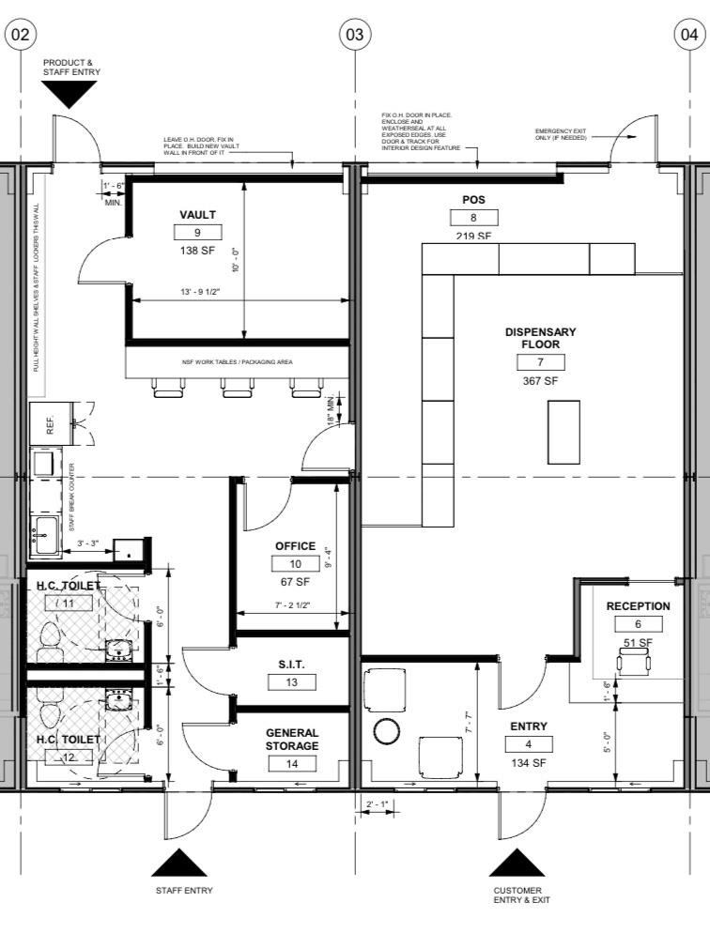
The specific layout and equipment described in the Exhibit is for illustrative purposes only and also subject to the approval of the CCC, and in no way limits Tenant’s ability to alter, replace, enhance, modify, supplement, refurbish, or upgrade any such layout and equipment within the Premises.

